DINISHA R

230701080

**DESIGN AND ANALYSIS OF ALGORITHM**

**COMPETITIVE PROGRAMMING**

1)

Find Duplicate in Array.

Given a read only array of n integers between 1 and n, find one number that repeats.

Input Format:

First Line - Number of elements

n Lines - n Elements

Output Format:

Element x - That is repeated

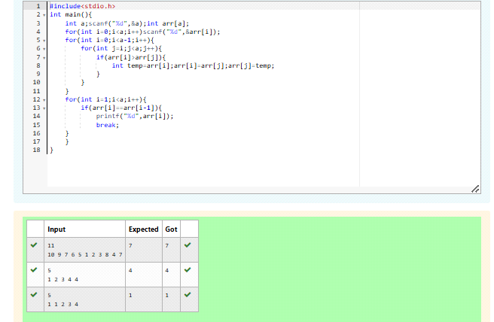

2)

Find Duplicate in Array.

Given a read only array of n integers between 1 and n, find one number that repeats.

Input Format:

First Line - Number of elements

n Lines - n Elements

Output Format:

Element x - That is repeated

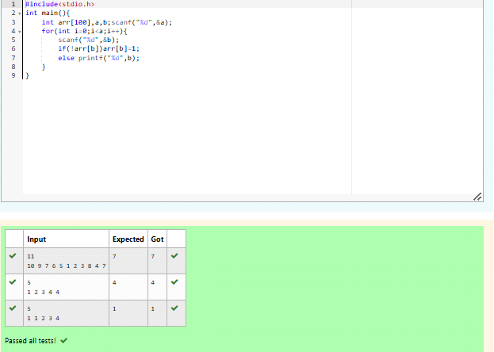

3)

Find the intersection of two sorted arrays.

OR in other words,

Given 2 sorted arrays, find all the elements which occur in both the arrays.

Input Format

·       The first line contains T, the number of test cases. Following T lines contain:

1.     Line 1 contains N1, followed by N1 integers of the first array

2.     Line 2 contains N2, followed by N2 integers of the second array

Output Format

The intersection of the arrays in a single line

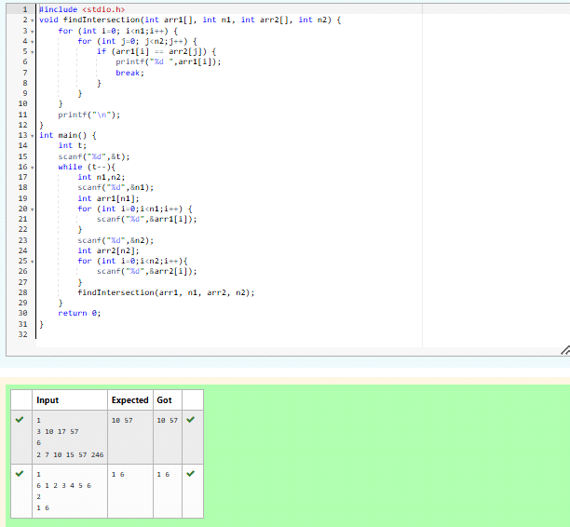

4)

Find the intersection of two sorted arrays.

OR in other words,

Given 2 sorted arrays, find all the elements which occur in both the arrays.

Input Format

·       The first line contains T, the number of test cases. Following T lines contain:

1.     Line 1 contains N1, followed by N1 integers of the first array

2.     Line 2 contains N2, followed by N2 integers of the second array

Output Format

The intersection of the arrays in a single line

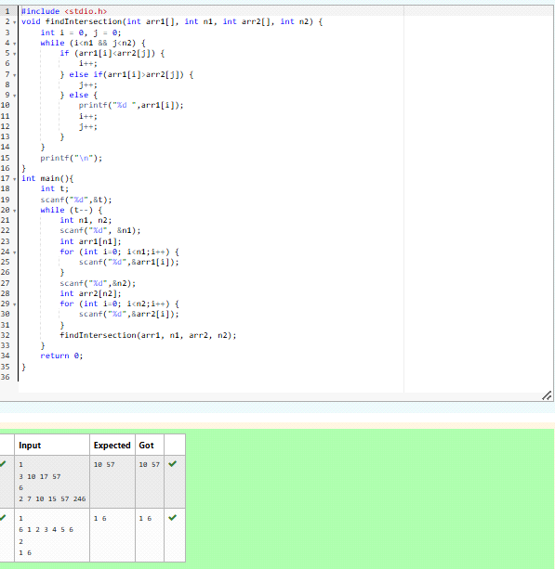

5)  
Given an array A of sorted integers and another non negative integer k, find if there exists 2 indices i and j such that A[j] - A[i] = k, i != j.

Input Format:

First Line n - Number of elements in an array

Next n Lines - N elements in the array

k - Non - Negative Integer

Output Format:

1 - If pair exists

0 - If no pair exists

Explanation for the given Sample Testcase:

YES as 5 - 1 = 4

So Return 1.

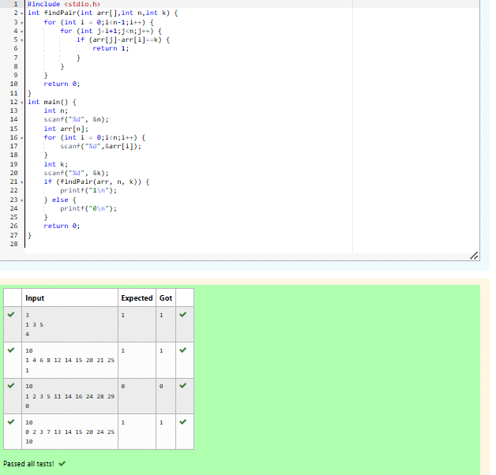6)

Given an array A of sorted integers and another non negative integer k, find if there exists 2 indices i and j such that A[j] - A[i] = k, i != j.

Input Format:

First Line n - Number of elements in an array

Next n Lines - N elements in the array

k - Non - Negative Integer

Output Format:

1 - If pair exists

0 - If no pair exists

Explanation for the given Sample Testcase:

YES as 5 - 1 = 4

So Return 1.

